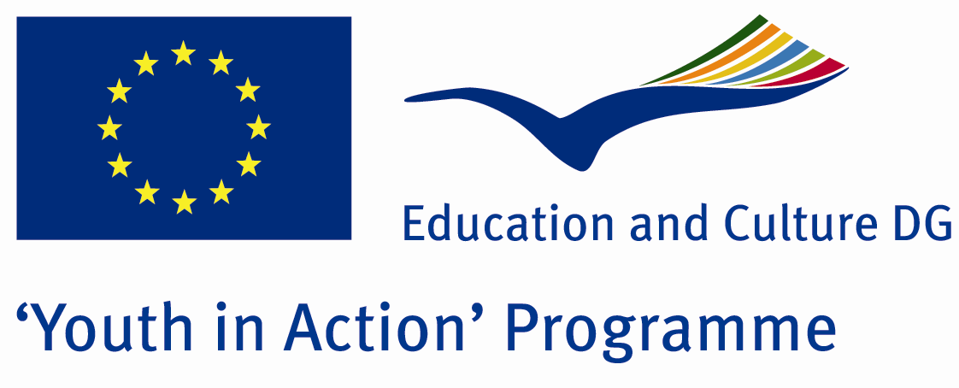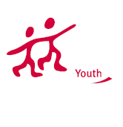

The Birth of Languages


ACTION 1.1 – Youth Exchange

20-27th August, 2011

Kilis, TURKEY

ACTION 1.1 - Youth Exchange
20-27th August, 2011
Kilis, TURKEY

Please contact directly to;
adventurerpeacepigeons@gmail.com

Project Summary;

Language is a tool for the deal among the people. Language is developing in each day, such as a living thing. There are 203 countries in the world and some of countries speak same language and some of countries speak more than 1 language. Therefore too many languages are spoken all over the world. Based on that we decided to do a project related to the birth of languages and history of the languages. We do this Project in Kilis. We chose this city because Kilis is very old city and Many civilizations lived here (Assyrian, Median, Parthian Empire, the Byzantine Empire, Seljuk Empire, Ottoman Empire, Britain, France, the Republic of Turkey) so that so many languages borned and spoken here. We will learn history of the languges, will visit historical and living places and all participants will teach their languges.

If you want to join this project, please contact us..

Project Title; The Birth of Languages

Date and Venue ; 20-27th August, 2011 Kilis, Turkey .

Target Group ; Municipalities, City Councils and Non-Governmental organizations,
youth groups,culture and art groups,e.t.c

Participants ; 5 people from each country (over 18 -25 ). Totally 8 countries.

Conditions ; Accommodation, board and programme costs will be financed through European Commission Youth in Action Programme (Action 4.3). Travel costs will be reimbursed in 70% (APEX Tarrifs). Organizations from all 27 EU member countries plus Liechtenstein , Norway and Iceland are eligible to take part.

Working language: English

Organizer; Adventurer Peace Pigeons

How to apply: If you are interested, please send your Part III forms to
0090 216 494 39 98 by FAX please. (Fulfilled Part III which you can find in the attachment, of course signed and stamped) ..

Note: jpeg is not allowed..please send by fax…

Next step 2;
Original send via regular post to this address please:

Ertan DERİN
Öner İnşaat
Abdulhalik Renda Cd.
Parlar Sk. No:4 Pendik/İSTANBUL

If you have any questions you may contact with: adventurerpeacepigeons@gmail.com

Deadline for application; until 20 March 2011.

For Further information:
Contact Person
Ertan DERİN
Öner İnşaat
Abdulhalik Renda Cd.
Parlar Sk. No:4 Pendik/İSTANBUL

e-mail : adventurerpeacepigeons@gmail.com
Mobile : 0090 542 393 93 90
Fax : 0090 216 494 39 98

